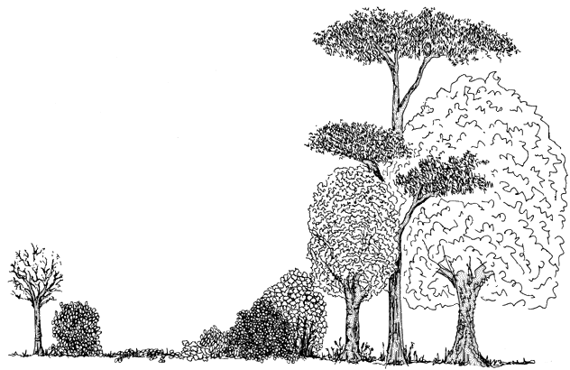

MARK FISHER
GARDEN PROJECTS
DESIGNS FOR A

COMMUNITY MARKET GARDEN

SANDALL GROVE PADDOCK
OLD KIRK SANDALL
DONCASTER

For the
GLASS PARK DEVELOPMENT COMPANY
Mark Fisher Dec 2000
01274 584089
mark.fisher@self-willed-land.org.uk
INTRODUCTION This is a report of the design process for an organic demonstration area, commissioned by the Glass Park Development Company, and based on a paddock of 0.4 hectare identified for development in Old Kirk Sandall. The process has involved the participation of members of the Glass Park Trust and builds on community aspirations recently confirmed in a report commissioned by the Trust and entitled Grove Farm Community Enterprise Centre - Business Plan.

The design process was based on a number of stages, and on the building of a relationship between the client and the designer. The client was encouraged to become an active member of the design team. In this capacity, the client was representing not just the direct commissioners of the work, but also the community of interest that the design is intended to serve.

The design was guided by the principles of sustainability, which integrate environmental with social and economic considerations. Thus the design sought to incorporate and interconnect the roles and functions of people and their productive, trading, educational and leisure activities with the enduring use of the land. The physical development of the land and its long-term use follow contemporary methods based on natural systems. These seeks to minimise environmental impact, maximise productive opportunity and rely on the re-use or recycling of wastes and resources.

DEVELOPING THE BRIEF As a preliminary, the client and members of the community were invited to fill in PASE Element Generator sheets (PASE stands for Plants, Animals, Structures and Events). This is a simple exercise used to identify the wants and needs of the client. The PASE sheets were reviewed at an onsite meeting with the client as the first step in developing a brief for the design.

The onsite meeting served two purposes. Review of the PASE sheets provides the broad context of the brief. The client interview that followed began to add detail and set the choices that had to be made in the design. This was carried out while walking the site as it helped to set the physical boundaries of the site, but also provided a picture of the general location in which the site exists.

THE CONCEPT REPORT After the site visit, a concept report was developed and then presented to the Glass Park Trust. This report took the form of schematics that identify the major elements of the design concept and how they connect with each other. As a follow up to this report, Trust members were circulated with a questionnaire that sought their opinion on particular aspects of the design that needed clarification. Based on responses, an overall design could commence.

THE OVERAL DESIGN was done in stages based on the logical sequence of development and the subdivisions of the land identified in the concept design. A Design Group of six Trustees received reports on each stage of the design, as well as the client, and comments were welcomed. Textual explanation and detail, in some cases, for particular design elements supported schematic representations of the design for the subdivisions. Quantities and indicative costings were also supplied. A schematic is supplied for the overall design and some observations are made in drawing together development actions.

CONTENTS

Results of the Questionnaire
The Design Phases
- Trees and Boundaries
- Boundaries and Fencing
- Public Space
- Secondary Space
- Growing Area
Overall Design

Appendix 1: Client Brief
Appendix 2: Design Proposal
Appendix 3: Design Questionnaire

DESIGN QUESTIONS

SANDAL GROVE PADDOCK – 20th September 2000

A total of eight Trustees responded to the Questionnaire (copy included in appendices). The results are shown in the table below. As a result of the responses, the inclusion of a pond and composting toilets were put on hold in the design process. A number of design suggestions accompanied the questionnaires (see below the table) and these will be incorporated where possible.

Question | YES | NO | MAYBE
PRIMARY AND SECONDARY SPACES | 7 | 0 | 1
TREE MANAGEMENT | 8 | 0 | 0
POND | 2 | 2 | 4
FENCING AND ACCESS POINTS | 8 | 0 | 0
COMPOSTING TOILETS | 4 | 3 | 1

1. Do you agree with the idea of primary and secondary spaces?

”I agree with the concept of primary and secondary spaces. The Victorian walled garden idea still holds good.”

“Supervision is clearly an important consideration. With this is mind I suggest allotments aimed at food production is considered. Agreements with local people taking over allotments should include discussion on a team approach to supervision.”

“The theory is excellent. However, I have found in practice that perceived undesirable people have a habit in frequenting these kind of areas and they soon become a no-go area for the community they were designed for by the fear of intimidation.”

2. Do you agree with the proposed management of the trees on the site?

“Coppicing and pollarding on a selective basis should prove beneficial.”

“Will there be enough wood to make our own charcoal?”

“the trees need to be managed.”

3. Do you want a permanent water feature, and where would you put it?

“Perhaps site usage should be monitored before pond installation, after which this decision could be made.”

“Bearing in mind that there is a pond in the parks and we have a canal a few yards away, another water feature could be viewed as superfluous.”

“Statistically, there are 10 deaths a year of children in ponds. If we go for a pond, we need to prevent access to children. This would detract from its appeal.”

“Safety. Could the pond be placed astride the inner fence, half is in the primary area with a barrier around it, and the other half is in the secondary area and without any barrier?”

“The choice between a safe pond and one which is a 100% wildlife habitat is a difficult one. Initially, safety is paramount.”

“A permanent water feature has many benefits. I was wondering if in order to minimise safety aspects, is it not possible to work on a bog garden system? A centre area could be deeper to have the functioning of a pond, while the bog area around it would create a barrier while also supporting wildlife and plants.”

“A super-safe pond placed in the primary space.”

4. Do you agree with the proposed fencing and access points?

“They appear to be effective”

“Can we grow things up the internal fencing?”

“Make the access points wheelchair and pushchair friendly.”

5. Should there be composting toilets?

“Will prove useful and cost effective.”

“There needs to be some form of toilets. However, the public are fickle about this sort of thing.”

“Provide these for the workers in the secondary area, with access during public events. This will help to keep maintenance down to a minimum.”

“Provide a solution to a problem, and they could also be quite educational for some people.”

“Only as a temporary measure until conventional toilets can be installed.”

TREES AND BOUNDARIES – SANDALL GROVE PADDOCK Oct 2000
 | Girth (m) | Height (m) | Volume (m³)

SYCAMORE
S1 | 1.21 | 7 | 0.52
S2 | 1.24 | 6 | 0.47
S3 | 1.23 | 7 | 0.54
S4 | 0.65 | 3.5 | 0.12
S5 | 1.13 | 4.5 | 0.30
S6 | 0.95 | 5.5 | 0.29
S7 | 0.6 | 4 | 0.11
S8 | 1.00 | 6 | 0.34
S9 | 1.03 | 5 | 0.29
S10 | 0.93 | 5 | 0.26
 | 1.11 | 8 | 0.53
 | 0.92 | 5 | 0.25
S11 | 1.32 | 6 | 0.52
S12 | 1.09 | 4 | 0.38
S13 | 1.32 | 5 | 0.43
 | 0.82 | 3 | 0.13
S14 | 0.70 | 5 | 0.18
S15 | 0.65 | 3.5 | 0.12
S16 | 1.12 | 5 | 0.33
S17 | - | - | -

OAK
01 | 0.76 | 6 | 0.24
02 | 0.96 | 4 | 0.21
Total cordwood |  |  | 6.56
Tree girths (i.e. circumference) were measured. The heights are an estimate of usable logwood length from ground level to a girth of about 0.65m (diameter of about 21cm). Note that some trees have more than one trunk. C1 to C3 and S17 were not worth measuring. The volume is an estimate of cordwood that will be removed – it omits smaller trunk and branch wood.
TREE MANAGEMENT The table to the right can be used in conjunction with the plan on a following page to identify the location and size of the trees that are proposed for coppicing. They are almost all sycamore, and most are adjacent to the central area on the SE and SW boundaries. In addition, one oak (O2) is in poor shape and another (O1) has previously been marked for removing. These trees are also marked on site with agricultural twine tied around the girth - one blue ring.

There are few candidates for pollarding other than a hawthorn and one of the oaks (O2). The sycamores behind the main line (S14 and S15) are better coppiced since sycamore has one of the more dense leaf canopies, and the location of these trees needs opening out. Trees for pollarding are marked with one loop of orange twine. There will also be some pollarding of the birch trees in the small self-sown birch wood to the extreme south (not ringed).

Only four trees at present are suggested for complete removal: S17 and C1 to C3. These will be cleared to make access for a new entry way in the northern perimeter. They are marked with two rings of blue twine.

An overhanging branch will be taken off one of the willows (W1).

An estimate of the volume of wood felled is shown in the table. Woodland management is regulated with a limit of 5 cubic metres of cordwood cut per quarter without licence. The total is just over the limit and so cutting will be over two quarters.

The intention has been to use the felled wood onsite in garden building. It is disappointing that almost all of it will be sycamore since it has no durability, decaying by five years. Oak will last up to 25 years and thus the preferment will be to coppice O2 along with O1 and retain the wood for building the outdoor class room/meeting room. A use for the sycamore logs will be given below. Its smaller branches and brash will be shredded for woodchips and used as mulch.

FENCING and BOUNDARIES Note that there are two options for the boundary line on the NE – a decision needs to be made with the developers. The NW line is new, to take account of the 6m easement from the wall. The metre or so of paddock now outside can be reclaimed at a later date with plantings after housing development is complete.

The NE and NW lines bound the public area and the proposal is to have a wooden post and double rail fencing (similar to that around the community orchard). The overall length is about 110m (without subtracting access points). The Trust has sufficient leftover rail for this, but not posts. The NE fence line will also be supplemented by hedge planting, with gaps where there is access. This will be about 50m of staggered double line hedging. A portion of old privet hedge will be retained on this line, but will be cut down to base to regenerate.

The SE line will have a boundary fence of stock netting with a single wire line between posts and stretching posts. The length is about 73m and it will be supplemented to the inside with a staggered double-line hedgerow.

The SW line of about 70m has a patched up fence line that is tightly bound by trees and saplings. Since we want to retain the trees inside and out, it will be difficult to thread a new, replacement fence along this line. It may be easier in the long run to bring the new fence line inside of the old one.

The extent of the internal growing space is fixed naturally by the root creep surrounding the central area. Taking the mature tree canopy as an indication, points were marked out and mapped on the ground. They can be observed on site as stones that have been embedded at each point in the turf. These markers give the minimum uninterrupted growing space (about 1,239m²), which has a boundary of about 125m. It will be enclosed with hexagonal-mesh rabbit fencing.

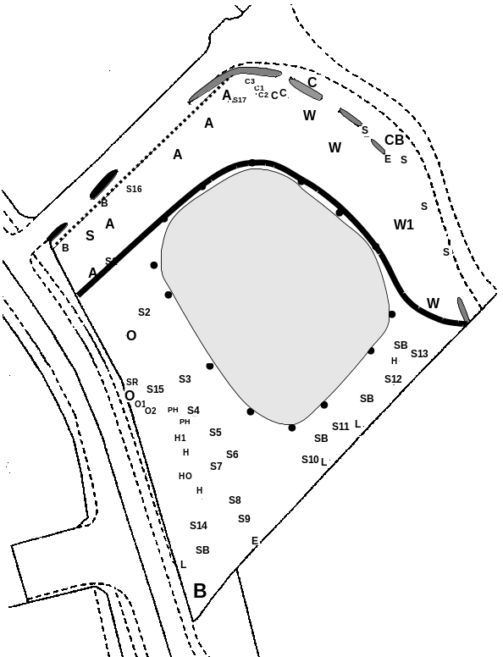
The broad band on the plan to the right shows the internal boundary between the public and secondary space (total length of about 89m). A major part of the northern arc of this line will be rabbit fencing. It will be added to at the E and W ends with post and two-rail fencing (combined length of about 40m, which uses up the leftover). Any access gates through the rail fencing will be lockable with no unsupervised access.
Boundary line between public and secondary space.
Public space
27%
Growing space
32%

To reinforce the separation between the public space and the secondary space, the boundary line will be supplemented by a log wall built from the sycamore logs (see figure to left – we will have sufficient for a height and width of 0.5m). This will also use up some of the larger branch wood and may be topped with turf and mounded with soil from path excavations. Its gentle decay over the years will not be critical as plantings either side will then have significant size.

New boundary line to allow for easement @ 6m from wall.
Remove old birch hedgeline
Remove old birch hedgeline.
Clear through for new access point – take out cherries and sycamore.
Retain this section of privet hedge, but remove the rest.
Boundary line follows old hedge line – or follow the line of sycamores outside it?
Tidy up this willow – take off overhangs.
Secondary internal boundary pushed south to increase primary public space.
Fence line bounded tightly by trees each side. Difficult to re-fence exactly along this line. Either leave untill later or re-fence inside of line.

Outside fence line has birch, field maple, oak, elder and many saplings. Ivy and bramble groundcover.
Small wood of birch saplings and trees. Coppice and pollard – underplant for woodland garden effect.
Dense offsite woodland. Implications for new fence.
A – ash
B – birch
C – cherry. C1 to C3 to remove
CB – copper beech
E - elderberry
H – hawthorn. H1 to pollard
HO – holly
L – laburnum
O – oak. O1&2 to coppice
PH – philadelphus
S – sycamore. S1 to S15 to coppice. S16 take off side branch. S17 remove
SB – silver birch
SR – specimen rowan (Sorbus)
W – weeping willow. W1 to tidy
Privet hedge
Birch hedge
Embedded stone
Internal growing space boundary established by marking the outer limit of the tree canopies surrounding the central space. This a minimum area for this space. The markers are stones embedded in the turf.
1:500 (approx.)
SCALE
Clear through to remove young birch saplings.
Concrete gate posts with fire hydrant in front.
SANDALL GROVE PADDOCK Nov 2000
Main entrance gate
Public access point
Public
access
point
Post & rail with
single hedge line
Main entrance to internal space
Post & rail
Single gate
Stock fencing and double hedge line
Rabbit fencing
Slip gate
Stock fencing
Stock fencing with shrubs in front
Single gate
Stock fencing
BOUNDARIES & FENCING

A listing of quantities and indicative cost is given overleaf for the boundary fencing and internal fencing for the paddock. A brief description is given for each. The major boundary of the public area to the NE and NW has options for the various types of gateway to allow good public access.

INTERNAL FENCE
Surrounding the growing area, this fence has to be rabbit-proof and so it has 31mm x 1.05m rabbit netting. The bottom 10cm is turned outwards and rests on the ground to prevent burrowing. The main gate is a lockable opening of 3m with two gates closing together. People swinging on a single gate of this width would damage it. Two sections takes this away and allows flexibility, with probably only one gate being open most of the time, but allowing vehicle access if needed. The other two gates are singles of 1.2m width. All gates will be netted to make them rabbit proof.

SOUTHEAST BOUNDARY
This is a near straight run of tensioned stockfencing, with one line of wire between the posts at the top. The mesh width is 15cm to deter dogs. A staggered double-line hedge will be planted on the inside, 50cm inwards and with 50cm between rows and within rows. The species will be a mix of holly, hawthorn, field maple, hornbeam, blackthorn, dog rose, crab apple, wayfaring tree, wild cherry and some elder and rowan.

INTERNAL LINKING FENCES
EAST A short length of stockfencing links the fence line on the southeast to the inner rabbit fence. This closes off the public space from the secondary space in this eastern corner. In front is planted an area of berried shrubs to include guelder rose, juneberry, barberry, sea buckthorn, oleaster, elder, rugosa roses and some specimen crab apples. There is no gate on this line.
WEST A line of stockfencing linking the rabbit fence in the western corner to the northwestern boundary. It has a lockable slip-gate for a low use entrance of 3m width.

NORTHEAST AND NORTHWEST BOUNDARY
This exterior boundary surrounds the public access space. It has a post and two-rail fence, with one line (possibly two lines) of wire to discourage wrecking or removal. The NE line of this fence will have a single hedge line planted inside at centres of 45cm.

The main entrance gate located at the northern point of the paddock can either be a single gate of 3.6m width or two gates of 1.8m. Again, the two gates give flexibility and reduce strain and the potential for damage.

There are various options for the two public access points either end of this long boundary. The objective is to allow general access, but to prevent bicycles, motorbikes, carts or other unwanted haulage equipment. Here is an escalation of options:

- The simplest answer is a stile for climbing over the fence at these two points. A stile will nevertheless rule out a less agile population.
- A squeeze gate or a kissing gate would do better. A squeeze gate has no moving parts compared to the kissing gate, but neither of these allow wheelchair access.
- A compromise would be to combine one of the latter three options with a lockable, single width gate on each boundary line, providing known wheelchair users with keys to these locks. However, this will not satisfy the spontaneous visiting of other wheelchair users.
- A boxed kissing gate design that allows wheelchair passage has been provided by the Fieldfare Trust of Sheffield. The design requires a purpose built hinge and keep assembly, but I have adapted it for building from easily available components. The gate swing of 180⁰ allows the potential for damage. I am also uncertain how practical an entry point it would be for a range of wheelchair users. It may just allow some unwanted access.
The relative cost of these options is not so important as is the aim for the type of access. Decisions to be made are:
- Are you in agreement with the use of double gates to span wide openings?
- What kind of mix of gates would you like to see for the two public access points on the NE-NW boundary?
BOUNDARIES AND FENCES – Quantities and Costings

 | INTERNAL FENCE
MAIN GATE Double gate
GATES | Entrance - 1.5m | 91.95 | 2 | 183.90
POSTS | 150x150 2.4m | 22.95 | 2 | 45.90
HINGE KITS | 18" | 17.95 | 2 | 35.90
THROW OVER GATE LOOP | 14" | 10.50 | 1 | 10.50
DROP BOLT | 18" | 10.95 | 1 | 10.95
DROP BOLT SLEEVE |  | 0.00 | 1
PADLOCK BOLT | 6" | 2.95 | 1 | 2.95
PADLOCK | Steel 70mm discus - stormproof | 11.64 | 1 | 11.64
SCREWS |  | 0.00 |  | 0.00
NETTING | To rabbit-proof gates | 0.00
STAPLES | 30mm | 0.18 | 36 | 6.48 | *
 | Total |  |  | 308.22
SECONDARY GATES
GATES | Entrance - 1.2m | 83.95 | 2 | 167.90
POSTS | 125 X 125 2.4m | 15.95 | 4 | 63.80
HINGE KITS | 12" | 16.95 | 2 | 33.90
SPRING LATCH KITS |  | 5.95 | 2 | 11.90
SCREWS |  | 0.00 |  | 0.00
NETTING | To rabbit-proof gates | 0.00
STAPLES | 30mm | 0.18 | 36 | 6.48 | *
 | Total |  |  | 283.98
FENCING
RABBIT NETTING | 31mm x 1.05m heavy 50m roll | 107.58 | 3 | 322.74 | *
FENCING WIRE | 4mm per metre | 0.17 | 89 | 14.69
INTERMEDIATE POSTS | 75mm 1.65 | 2.05 | 12 | 24.60
STRAINING POSTS | 125mm 2.1m | 7.15 | 6 | 42.90
STRUTS | 100mm 1.8m | 3.15 | 6 | 18.90
THRUST POSTS, CROSS MEMBERS | 100mm 1.65m half rnd | 1.50 | 3 | 4.50
STAPLES | 40mm | 0.27 | 36 | 9.72
FASTENERS |  | 0.00 |  | 0.00
 | Total |  |  | 438.05
 | ELEMENT TOTAL |  |  |  | 1,030.25
SOUTHEAST BOUNDARY
SOUTHEAST FENCE LINE
STOCK FENCING | C8/80/15 medium | 46.45 | 2 | 92.90
STRAINING POSTS | 125mm 2.1m | 7.15 | 6 | 42.90
STRUTS | 100mm 1.8m | 3.15 | 2 | 6.30
THRUST POSTS, CROSS MEMBERS | 100mm 1.65m half rnd | 1.50 | 1 | 1.50
INTERMEDIATE POSTS | 75mm 1.65 | 2.05 | 30 | 61.50
FENCING WIRE | 4mm per metre | 0.17 | 73 | 12.05
STAPLES | 30mm | 0.27 | 150 | 40.50
STRAINERS | Rachet | 2.50 | 2 | 5.00
 |  |  |  | 262.65
SOUTH EAST HEDGE LINE
HEDGING SHRUBS AND TREES | Whips 40-60cm double row | 0.48 | 292 | 140.16
TEXTILE GROUND COVER | Phormisol 1m x 100m | 41.45 | 1 | 41.45 | *
 | Total |  |  | 181.61
 | ELEMENT TOTAL |  |  |  | 444.26
NORTHEAST AND NORTHWEST BOUNDARY
FENCING Two rail plus wire
POSTS (centres @ 2.1m) | 150 X 75 1.8m | 7.10 | 74 | 525.40
RAILS | 100 x 32 4.2m | 4.70 | 74 | 347.80
NAILS | 75 x 3.75 | 0.00 | 666 | 0.00
FENCING WIRE | 4mm per metre | 0.17 | 110 | 18.15
STAPLES | 40mm | 0.27 | 74 | 19.98
 | Total |  |  | 911.33
NORTH EAST HEDGE LINE
HEDGING SHRUBS AND TREES | Whips 40-60cm single row | 0.48 | 150 | 72.00
TEXTILE GROUND COVER | Phormisol 50m x 100 | 20.75 | 1 | 20.75 | *
 | Total |  |  | 92.75
MAIN GATE Double gates
GATES | Entrance - 1.8m | 98.95 | 2 | 197.90
POSTS | 150x150 2.4m | 22.95 | 2 | 45.90
HINGE KITS | 18" | 17.95 | 2 | 35.90
THROW OVER GATE LOOP | 14" | 10.50 | 1 | 10.50
DROP BOLT | 18" | 10.95 | 1 | 10.95
DROP BOLT SLEEVE |  | 0.00 | 1
SCREWS
PADLOCK | Steel 70mm discus - stormproof | 11.64 | 1 | 11.64
LOOPED SECURITY CABLE | 2.1 x 10mm | 8.79 | 1 | 8.79
 | Total |  |  | 321.58
 | PARTIAL ELEMENT TOTAL |  |  |  | 1,325.66
OPTIONS
MAIN GATE Single gate
GATE | Entrance - 3.6m | 158.95 | 1 | 158.95
POSTS | 150 X 150 2.4m | 22.95 | 2 | 45.90
HINGE KIT | 24" | 18.95 | 1 | 18.95
SPRING LATCH KIT |  | 5.95 | 1 | 5.95
SCREWS |  | 0.00 |  | 0.00
PADLOCK | Steel 70mm discus - stormproof | 11.64 | 1 | 11.64
LOOPED SECURITY CABLE | 2.1 x 10mm | 8.79 | 1 | 8.79
 | Total |  |  | 250.18
STILE
POST | 100 x 100 1.8m | 5.85 | 1 | 5.85
POST | 100 x 100 2.1m | 6.85 | 1 | 6.85
RAIL | 75 x 47 3.6m | 4.44 | 1 | 4.44
STEP | 175 x 50 0.9m | 3.55 | 1 | 3.55 | **
STEP SUPPORTS | 150 x 75 1.8m | 7.10 | 1 | 7.10
COACH BOLTS | M10 130mm | 0.98 | 6 | 5.91
NAILS | 125 x 5.60mm | 0.00 | 20 | 0.00
 | Total |  |  | 33.70
SQUEEZE
POSTS | 100 x 100 1.8m | 5.85 | 4 | 23.40
RAILS | 100 x 32 1.8m | 4.70 | 3 | 14.10
NAILS | 75 x 3.75 | 0.00 | 20 | 0.00
 | Total |  |  | 37.50
KISSING GATE
POSTS | 100 x 100 1.8m | 5.85 | 2 | 11.70
POSTS | 100 X 75 1.8m | 4.40 | 2 | 8.80
GATE | Entrance - 900mm | 73.95 | 1 | 73.95
HINGE KIT | 12" | 16.95 | 1 | 16.95
RAILS | 100 x 32 1.8m | 4.70 | 3 | 14.10
NAILS | 75 x 3.75 | 0.00 | 24 | 0.00
 | Total |  |  | 125.50
SMALL GATE
GATE | Entrance - 1.2m | 83.95 | 1 | 83.95
POSTS | 125 X 125 2.4m | 15.95 | 2 | 31.90
HINGE KIT | 12" | 16.95 | 2 | 33.90
THROW OVER GATE LOOP | 6" | 4.95 | 1 | 4.95
SCREWS |  | 0.00 |  | 0.00
PADLOCK | Steel 70mm discus - stormproof | 11.64 | 1 | 11.64
LOOPED SECURITY CABLE | 2.1 x 10mm | 8.79 | 1 | 8.79
 | Total |  |  | 175.13
KISSING GATE (wheelchair)
POSTS | 100 x 100 1.8m | 5.85 | 2 | 11.70
GATE | Entrance - 1200mm | 83.95 | 1 | 83.95
HINGE KIT | 12" | 16.95 | 1 | 16.95
THROW OVER GATE LOOP | 6" | 4.95 | 1 | 4.95
POSTS | 100 X 75 1.8m | 4.40 | 5 | 22.00
RAILS | 100 x 32 3m | 3.36 | 6 | 20.16
RAILS | 100 x 32 2.4m | 2.69 | 3 | 8.07
NAILS | 75 x 3.75 | 0.00 | 48 | 0.00
 | Total |  |  | 167.78
INTERNAL LINKING FENCES
EASTERN CORNER
EAST FENCING
STOCK FENCING | C8/80/15 medium | 46.45 | 0.5 | 23.23
STRAINING POSTS | 125mm 2.1m | 7.15 | 2 | 14.30
STRUTS | 100mm 1.8m | 3.15 | 2 | 6.30
THRUST POSTS, CROSS MEMBERS | 100mm 1.65m half rnd | 1.50 | 2 | 3.00
INTERMEDIATE POSTS | 75mm 1.65 | 2.05 | 5 | 10.25
FENCING WIRE | 4mm per metre | 0.17 | 15 | 2.48
STAPLES | 40mm | 0.27 | 25 | 6.75
STRAINERS | Rachet | 2.50 | 2 | 5.00
 | Total |  |  | 71.30
SOUTHEAST SHRUB AREA
SHRUBS berried | Whips 40-60cm | 0.50 | 33 | 16.50
SPECIMEN TREES | Light standard | 8.90 | 5 | 44.50
 | Total |  |  | 61.00
 | ELEMENT TOTAL |  |  |  | 132.30
WESTERN CORNER
WEST FENCING
STOCK FENCING | C8/80/15 medium | 46.45 | 0.5 | 23.23
STRAINING POSTS | 125mm 2.1m | 7.15 | 4 | 28.60
STRUTS | 100mm 1.8m | 3.15 | 4 | 12.60
THRUST POSTS, CROSS MEMBERS | 100mm 1.65m half rnd | 1.50 | 2 | 3.00
INTERMEDIATE POSTS | 75mm 1.65 | 2.05 | 7 | 14.35
FENCING WIRE | 4mm per metre | 0.17 | 25 | 4.13
STAPLES | 40mm | 0.27 | 42 | 11.34
STRAINERS | Rachet | 2.50 | 4 | 10.00
 | Total |  |  | 107.24
SLIP GATE
INTERMEDIATE POSTS | 75mm 1.65 | 2.05 | 2 | 4.10
RAILS | 100 x 32 3.6m | 4.03 | 7 | 28.21
COACH BOLTS | M10 x 75mm | 0.28 | 15 | 4.20
HASP AND STAPLE | 8" | 4.50 | 1 | 4.50
PADLOCK | Steel 70mm discus - stormproof | 11.64 | 1 | 11.64
 | Total |  |  | 52.65
 | ELEMENT TOTAL |  |  |  | 159.89

PUBLIC SPACE - SANDALL GROVE PADDOCK Dec 2000

The schematic plan of the Public Space shows a representation of the canopies of the various trees on the paddock and this is helpful in allowing us to see the design possibilities. In the case of the two public access points, it provides strong indications of where these should be located, as it does for the outdoor classroom/meeting room which fits well in a space along the NE line.

The overall design of the Public Space is made up from a number of elements. A brief description of each is given and quantities and indicative costs can be found at the back.

PATHS AND HARDSTANDING
One of the quickest ways to section up an area is to fill-in the natural path and track routes through a site. The principle is that every area should be served by some access and, in this case, the gates on the outer and inner boundaries are logical destinations. As can be seen in the schematic, the paths and track create five main areas in the public space, each of which may be developed thematically later on.

The paths and track need to have a non-moveable surface if they are to be suitable for wheelchairs. Road planings or brick dust would work, but availability may be difficult. A source of ballast that can be packed down will need to be identified locally. This will be laid on a geotextile to prevent the ballast mixing into the soil, prevent weed growth and give longer life to the paths and track. Paths will be a minimum width of 1.2m.

At points along the path, areas of hardstanding are incorporated which allow for passing and rest stops (as recommended by the Field Fare Trust) and one is incorporated into the outdoor classroom. This hardstanding will also need to taken through and outside the two public access points.

OUTDOOR CLASSROOM/MEETING ROOM




This element fits in well in the open space along the NE line. It is a simple concept of providing a variety of seating styles in an informal setting. The upright and horizontal logs will come from the coppicing of the two oaks from the SW boundary. They will be secured in place either by posts or underground cross pegging for the uprights. The tyre wall will have the tyres bolted together and the structure will be filled with soil from excavation of the central area. The idea is to create a grassy mound. The post and rail are sitters or back rests. The central area will be woodchip mulch over geotextile (a soft surface) the woodchip coming from the brash created by coppicing sycamores over the site.
3.5m
6m

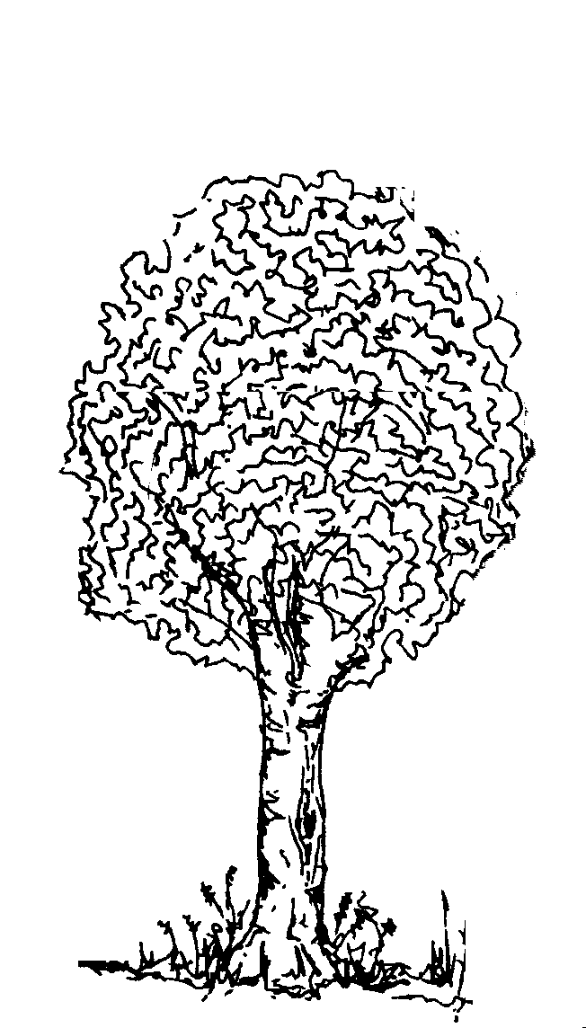

TREE SEATS
1.2m
A simple way to incorporate seating in this location is to use circular tree seats. They can be partially constructed away from site and the last section bolted together around the tree when the seat is in place. They will afford shaded seating in summer and have the advantage of a built-in backrest.

They will be difficult to fix into the ground, but the encircling nature makes them un-removable. Pressure treated wood will be used for the seat boards if it can be found planed-all-round (PAR). If not, a suitable wood preservative stain will finish.

There are three tree seats marked on the schematic. More can be specified if required. Open site benches could also be put in if desired.

NOTICEBOARD
An important public face for the community garden (and presumably also the Trust) this noticeboard can create a vertical accent along the throughway of the public space. Some permanent information/interpretation about the site can be posted along with news of workparty days, forthcoming events in the outdoor meeting room and harvest celebrations.
2.4m
1.8m
0.6m
1.2m
1.2m
1.8m

The roof sheltering keeps off the weather elements that always seem to degrade notices on open boards. It will also provide temporary shelter for a few caught in a downpour (its dimensions could be larger if a lightweight metal roofing was used instead of featherboarding).

The structure is held in place by the posts being sunken and the structure is stiffened by diagonal and cross bracing. While pressure treated wood will be used as much as possible, the structure would benefit from an overall colour from wood staining. The ground inside the structure would need to be made into hardstanding.

WET AND DRY GARDEN
The reservations over open water in the public space brought the suggestion that a bog garden would be safer and I have borrowed this idea. In designing a garden feature, I had in mind the use of the large and irregular shaped glass blocks that were rescued when the Millennium Green was being constructed. They cry out to be used to represent a dry riverbed, but to get some height into the feature, I have shown them as a dry beck running down to the bog garden. The bog garden is created by running a pond liner under the soil (with some light puncturing) improving the soil by incorporating organic matter and also mulching out with it, thus markedly increasing moisture retention. The bog garden will be planted with bistorts, royal fern, meadowsweet and masterwort.
2.7m
5.1m
30cm
25cm
15cm

The height is created by a rockery made from upright clay drainage pipes of two diameters. Using thirds of the total length of these pipes, the back of the rockery rises in three layers and falls as a filled three dimensional horseshoe. The pipes and rockery will be planted with a collection of small and prostrate thymes.

The rear of the rockery is a gravel garden, made by incorporating shingle into the soil to 15cm depth and mulching out with shingle. This will be sparsely planted with sea holly, ornamental onions, kaffir lily, blue african lily, a spurge and a collection of short, coloured, ornamental grasses.

LANDSCAPING
The log walls around the outside of the rabbit fence have been described previously. Soil from the track and path excavations will be banked-up to these and they will be strewn each year with insect attracting annuals (nasturtium, poached egg, opium poppy, borage and pot marigold) and short-lived perennials (iceland poppy, columbine) and some small annual, ornamental grasses (quaking grass). A good seed bank will build up over the years, making it less work.

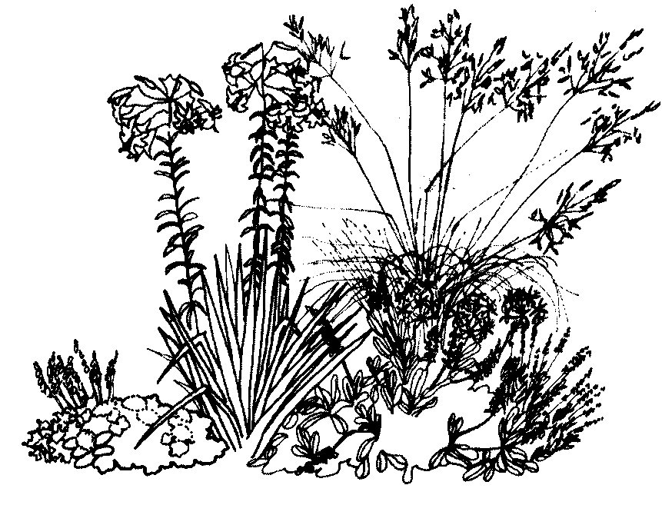
The single hedgeline along the NE boundary can be underplanted with hedgerow plants such as red campion, green alkanet, lord’s and ladies, deadnettle and periwinkle. A few native honeysuckles can be run up through the hedge. All these plants are best established from plug or pot plantings.

There is a lot of rough pasture that should be managed rather than cleared. The unwanted wildflowers should be mostly spot-removed with a fork, like ragwort, docks and nettles. The pasture should be managed by strimming and possibly mowing, but leaving some curving banks or strips untouched. Areas nearer the trees can be planted up over the years with spring flowering (snowdrop, crocus and daffodil) and autumn flowering (colchicum and cyclamen) bulbs. Other areas can be gradually planted up with grassland perennials and suitable garden perennials to produce the ecological drift planting seen in Heem parks in Holland and Westpark in Munich. Again these have very low maintenance once established, and are cut only once a year.
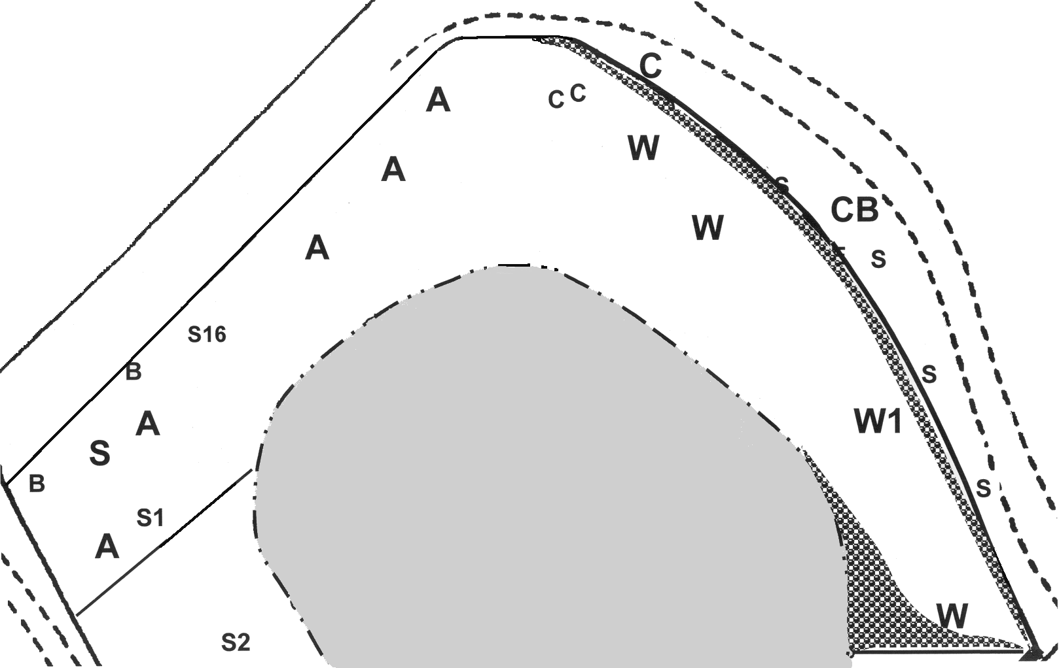
Log wall
Wet and Dry garden
Tree seats
Noticeboard
Coppiced sycamore
Hardstanding
Outdoor classroom
Willow
Copper beech
Cherry
Birch
Sycamore
Ash
Scale about 1:300
Hedging
PUBLIC SPACE – Quantities and Costing

PATHS AND HARDSTANDING
BALLAST | < 20mm - per ton (TBD ) | 22.50 | 25 | 562.50
GEOTEXTILE | Terram 1000 4.5m roll, per metre | 3.50 | 40 | 140.00
 | Total |  |  | 702.50
OUTDOOR MEETING ROOM
OAK LOGS | Various - onsite | 0.00 | 10 | 0.00
TYRES | Various - nearby | 0.00 | 30 | 0.00
BOLTS | M10 40mm zinc | 0.09 | 50 | 4.50
NUTS | M10 zinc | 0.08 | 50 | 4.00
WASHERS | M10 zinc | 0.06 | 50 | 3.00
JUMP POLE | 100mm round 3.6m | 9.85 | 4 | 39.40
POST | 75mm round 3m | 4.75 | 2 | 9.50
SCREWS | M10 130mm Coach zinc | 0.44 | 16 | 7.04
WOODCHIP | Chipped on site - cubic metres | 0.00 | 1.5 | 0.00
GEOTEXTILE | Terram 1000 4.5m roll, per metre | 3.50 | 6 | 21.00
 | Total |  |  | 88.44
TREE SEATS
BOARD | 150 x 47mm per metre | 2.45 | 8 | 19.60
POST | 75 x 75mm 1.5m | 2.75 | 8 | 22.00
SCREWS | 6 X 100mm SPAX | 0.07 | 160 | 11.20
TREATMENT | Sadolin Xtra per litre | 13.00 | 1 | 13.00
 | Total |  |  | 65.80
 | ELEMENT TOTAL |  | 3 |  | 197.40
NOTICEBOARD
POSTS (Upright) | 100 X 100mm 3m | 9.75 | 4 | 39.00
POSTS (Diagonals) | 100 x 75mm 2.4m | 7.30 | 2 | 14.60
POSTS (Roof) | 75 x 75mm 2.4 | 4.40 | 4 | 17.60
POSTS (Roof) | 75 x 75mm 3m | 5.50 | 3 | 16.50
FEATHER EDGE | 150 X 22mm 2.4m | 1.48 | 20 | 29.60
COPING | 2.4m TBD | 0.00 | 1 | 0.00
RESTRAINT STRAPS | 1000 X 30mm galv. | 4.03 | 4 | 16.12
RAIL | 100mm 3.6m half round | 4.50 | 2 | 9.00
FENCE PALE | 100 X 19mm 1.8m | 1.11 | 2 | 2.22
MATCH BOARDING | 125 x 19mm V join per metre | 1.15 | 26 | 29.90
NAILS |  | 0.00 | 0 | 0.00
SCREWS | 6 X 100mm SPAX | 0.07 | 100 | 7.00
TREATMENT | Sadolin Xtra per litre | 13.00 | 2.5 | 32.50
 | Total |  |  | 214.04
WET AND DRY GARDEN
CLAY PIPE | 19 X 30cm | 4.00 | 20 | 80.00
CLAY PIPE | 13 X 30cm | 2.87 | 20 | 57.40
POND LINER | 3.65 x 2.44m Lotus | 17.50 | 1 | 17.50
SOIL CONDITIONER | Composted manure 50L | 2.30 | 10 | 23.00
MULCH | Composted bark 80L | 3.20 | 2 | 6.40
SHINGLE | 10mm per ton | 22.00 | 1 | 22.00
PLANTS Dry garden | Budget | 50.20 | 1 | 50.20
PLANTS Rockery | Collection of 12 | 15.25 | 2 | 30.50
PLANTS Bog | Budget | 32.30 | 1 | 32.30
 | Total |  |  | 319.30
LANDSCAPING
HEDGEROW UNDERPLANTING | Budget | 120.00 | 1 | 120.00
ANNUALS SEEDING | Budget | 30.00 | 1 | 30.00
 | PUBLIC SPACE TOTAL |  |  |  | 1,671.68
SECONDARY SPACE - SANDALL GROVE PADDOCK Dec 2000

The secondary space of the design encompasses the main growing area in the centre and the ancillary space around it to the south. I am waiting on information from an OCIS advisor on suitable cultivation of the main growing area and so this concentrates on descriptions of the elements of the ancillary space (see schematic plan).

The ancillary space serves a number of functions, many of which are in support of the main growing area. Thus there are compost and leafmold bins and comfrey beds for fertility, and coppice wood to provide stakes and supports. The various permanent plantings of this area will also create a range of habitat that will draw in pest predators.

While not receiving the most sunlight, the area has a productive capacity that can be used for top and bush fruit, herbs for cutting and, in the shadier areas, cane fruit and rhubarb. Fruit is a particularly seasonal produce, but juicing and preserving can extend its use. (A connection with a yoghurt maker would be useful.) Novel condiments can be made from rhubarb or top fruit jellies flavoured with herbs such as rosemary, mints and thymes. Added value just needs a little imagination.

A functioning horticultural site needs space for propagation and this is provided by beds that can be used for tree and shrub seeds needing vernalisation, hardwood cuttings and for bulking out perennials for lifting and splitting. Turf stacks along with organic matter from composting will serve as the ingredients for potting media after propagation.

The elements of this secondary space are briefly described and quantities with indicative costs are given at the back. As with all designs, space should be left for future development. This is identified and possible future uses given for it. There are two general handouts appended on herbs and fruit for your interest.

BUSH AND TREE FRUIT
Experience has shown that the tallness of tree fruit such as the pomes (apples and pears) and stone fruit (plums, gages, damsons and cherries) can be combined with the lower growing bushy fruits (currants and gooseberries) in a series of triangular forest edges, the open side of the edges being orientated towards the sun. There is some tolerance in this arrangement because of the fact that fruit trees do not make very dense canopies. The advantage is the closer spacing than is conventional, combined with the variety that can be packed into quite amorphous areas.

The area below the linking fence in the E and down to the southern apex of the growing area can be put down to top and bush fruit. This is shown in a series of large curving beds. Ground preparation will be general strimming followed by removing turf where trees or bushes are to be planted and the planting holes and mixture improved with organic matter and some bonemeal. Fruit trees will be on moderate dwarfing stock (i.e. MM106 and M26 for apples) and will be staked and tied. The odd flowering perennial will be planted as an insect attractant and the whole will be mulched out with straw. Paths will be left as grass and will need managing. The gate from the growing area opens into this space.

HERBS
The more Mediterranean-like herbs need plenty of sun and good drainage to get them through wet and cold winters. Herbs are best grouped together for growing based on their habitat preference and nutrient need (see handout). Thus the herb area is shown as a series of teardrop shaped beds fitting together as a whole. The beds will be cleared of surface vegetation and prepared either by incorporating bulky organic matter, shingle or a combination of both. Beds will be mulched out after planting. Paths between the beds will be mulched out with woodchip over landscape textile.

CANE FRUIT
There are many hybrid berries available nowadays, such as tayberries, loganberries and boysenberries that are a success with children. These grow in the form of canes – like the raspberries and blackberries – and thus need the support of posts and wires (three or four lines). Raspberry varieties are also numerous, giving a spread of harvest from early, mid and late season croppers. Autumn raspberries can grow freestanding and are shown spaced around and within the support wire area. All cane fruit are shallow rooters needing good moisture and appreciating some shade. Mulching out with straw will follow good ground preparation with organic matter. Grass paths and surroundings to be managed.

RHUBARB
The paddock is perhaps only 40 miles away from the Yorkshire rhubarb triangle and a National Collection of rhubarb exists at the Harlow Carr Botanical Gardens near Harrogate. And yet many people are still not quite sure what rhubarb is (originally a native of Russia and Asia). Its use is also underestimated (see above) and it is something almost for nothing. Rhubarb is easy to grow, accepting some shade, and has many cultivars that spread the season from early to late. It needs a moist soil with good nutrient and so a series of deeply prepared beds will be made and planted with a variety of rhubarb cultivars

COMFREY BEDS
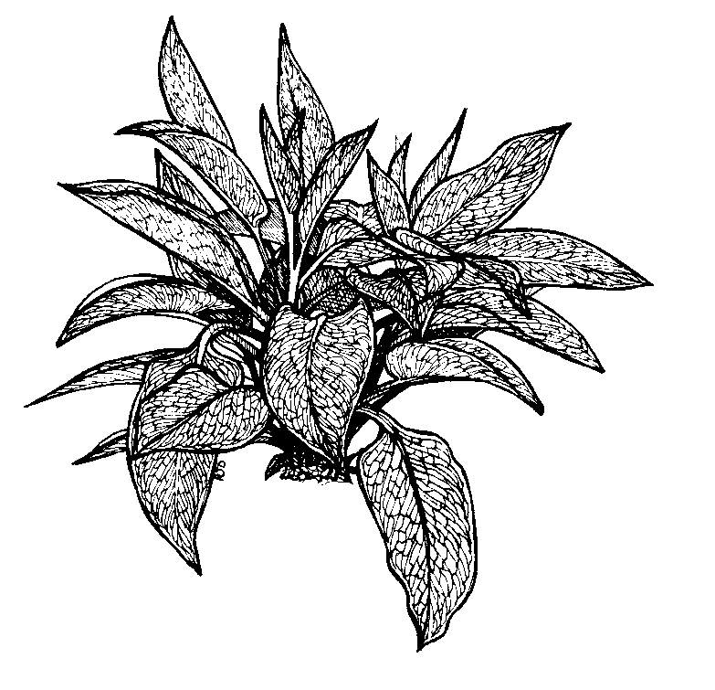
Comfrey is a deep-rooting native perennial that has traditional horticultural use in making liquid plant feeds and in using as a living, cuttable mulch. In past times, its common name was knitbone as it was thought to aid recovery of fractures. It was a significant source of cattle fodder and there have been attempts to use its mucilaginous quality to make an adhesive for postage stamps. All we need to know is that comfrey is a dynamic accumulator of deep soil minerals (particularly potassium) and will grow in partial shade. It will grow in the area between the SW boundary line and the first row of small trees in from the boundary, making use of a difficult area of the ancillary space. A Russian comfrey will be planted (a cross between our native and one from the Caucasus Mountains) that has been selected for leaf growth over flower production (Bocking 14, named after the trial grounds in Bocking, Essex). The beds will need clearing of the turf and will be planted up in staggered rows at centres of 45-60cm. A large number of plants will be needed for this and it is proposed to propagate the majority of these in the first year from root cuttings.

COMPOST AND LEAFMOLD BINS

In natural growing systems, soil fertility is aided by recycling plant wastes to the soil after composting. The design of the compost bin is not so important as is the accessibility and ease of use, so that composting becomes second nature. The compost bins have been located immediately opposite the second gate exit from the main growing area. The layout is two banks of three rectangular bins back to back. This arrangement allows for easy turning of the heaps from bin to bin in the bank, an essential part of the composting process. It also overcomes the common problem of composting that fresh material continues to be added over time, creating a heap with a range of state of decomposition. With this bank system, there can be a sequential throughput of material at discrete time intervals. The bins will be made from posts set in the ground and planking forming the carcass. The fronts of the bins will have removable slats to gain access. Heaps should be covered, but a lid system on this scale is impractical when some plastic sheeting over the contents of each bin will suffice.

Deciduous trees are the ultimate temperate climate recyclers of soil minerals. Roots penetrating into subsoil bring up minerals which are shed as leaves in autumn, allowing some of those minerals to be redistributed into the topsoil when the leaves rot in. Thus fallen leaves should not be wasted, but collected and returned to the soil. The lignin in leaves is broken down by fungi and thus is a different process than composting other waste materials. Leaves just need to be confined and kept moist, and bins made from posts and rabbit wire are sufficient. Again, three are specified to allow sequential heaps as it takes between one and two years before the leafmold becomes usable.

PROPAGATION BEDS

Whether for sale or for further site development, the propagation of plants is an intrinsic activity for a centre of horticultural endeavour. As with composting, the provision of easily used and accessible facilities again ingrains this. Propagation does not need the best of sunshine since cuttings and divisions are under stress already without being forced to search for excess water. The location for the propagation beds provides somewhat of a gradient of light conditions, the less intense being nearer the boundary. Experience has shown that hardwood cuttings would do best there whereas rooted plant divisions would bulk up with more light. Turf will be removed and the beds will be formed from pressure treated shuttering wood, held in place by nailing to driven batten. The soil in the beds will have shingle added to create sharper drainage, but also to make it easier to lift rooted cuttings and divisions without damage to the new roots.

LANDSCAPING AND BANKED SPACES
Quantities of turf will be produced during development of this space. The soil with this turf is a best quality asset, not to be wasted, and so the turves will be stacked in suitable locations along the SW boundary. After one or two years, the loam resulting from rotting-in of the vegetation will make a good ingredient for potting mixes or for fine garden feature building (any seed banks in this soil can be reduced by heat sterilisation or stale seed bed techniques).

Tree seedlings along the SW boundary will be removed to the lineout beds on the Millennium Green. The grass areas remaining after development will need managing, but leaving some strips untouched for habitat.

Two areas have been left undeveloped (and are thus space in the bank). A band of about 2-3 meters width runs from the W linking fence around the outside of the main growing area to nearly its apex in the S. This band will have reasonable sun and its potential future uses can be for production of dried (everlasting) flowers and seed heads (such as statice, safflower, poppy etc.) and cut perennial flowers, both for the florist trade. I considered part of it for strawberry production, but these are difficult to grow well for sale in this country without chemical pest control (most organic strawberries are imported from countries that are warmer, where they are grown at altitudes above 250m). Alpine-like wild strawberries are easier, but the fruits are too small commercially.

The second banked space is at the southern most tip (marked B on the schematic). This triangular area has a thicket of seeded birch and is heavily shaded by the small wood that is offsite below it. This level of shade precludes much, but there is the likelihood that the woodland below may not survive the housing development. Thus it is probably best to await what happens offsite before committing this area. Its potential is for a water feature. Its short-term use is likely to be for a screened-off straw bale urinal for those undertaking the early development of the site.
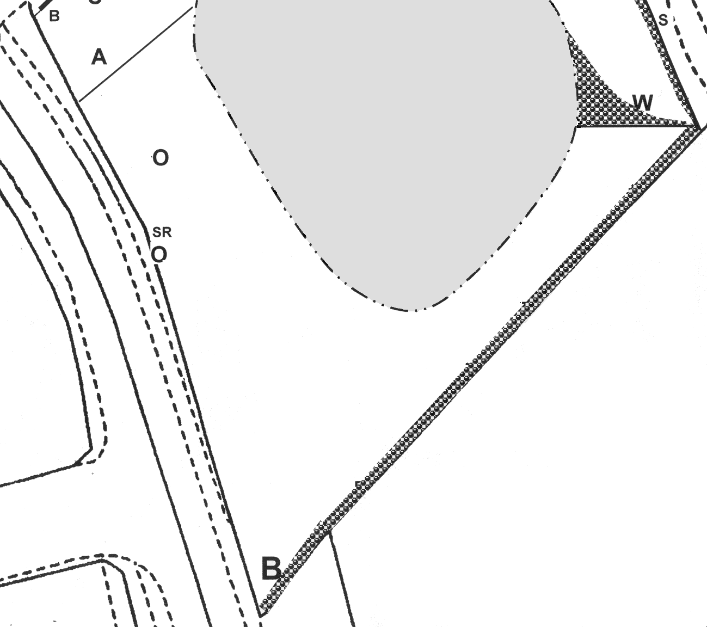
Coppiced oak

Oak

Silver birch

Laburnum

Hawthorn

Holly

Philadelphus

Coppiced sycamore
SCALE
about 1:400
Hedging

Propagation beds

Compost bins

Leafmold stacks

Comfrey beds
Bush & tree fruit bed

Herb bed

Rhubarb bed

Cane fruit wires

Autumn raspberries
SECONDARY SPACE – Quantities and Costings

BUSH AND TREE FRUIT
BONEMEAL | 25Kg | 16.44 | 1 | 16.44 | *
SOIL CONDITIONER | Composted bark per 80L bag | 3.76 | 15 | 56.40
STRAW | per bale | 1.00 | 75 | 75.00
TOP FRUIT | per tree | 11.00 | 16 | 176.00
TREE STAKE | 60 mm 1.65m | 1.70 | 16 | 27.20
TREE TIE | Buckle, 38cm | 0.31 | 16 | 4.96
TREE GUARD | Spiral, 60cm | 0.23 | 16 | 3.68
BUSH FRUIT | per bush | 2.00 | 28 | 56.00
 | Total |  |  | 415.68
HERBS
SOIL CONDITIONER | Composted bark per 80L bag | 3.76 | 24 | 90.24
SHINGLE | 10mm per ton | 22.00 | 3 | 66.00
WOODCHIP | Chipped on site - cubic metres | 0.00 | 3 | 0.00
GEOTEXTILE | Phormisol 1m roll, per metre | 0.41 | 40 | 16.40
HERBS | Budget | 150.00 | 1 | 150.00
 | Total |  |  | 322.64
CANE FRUIT
POSTS | 75mm 2.4m | 3.25 | 12 | 39.00
POSTS | 75mm 3.0 m | 4.75 | 3 | 14.25
THRUST POSTS, CROSS MEMBERS | 100mm 1.65m half rnd | 1.50 | 3 | 3.00
FENCING WIRE | 4mm per metre | 0.17 | 110 | 18.15
STAPLES | 30mm | 0.18 | 36 | 6.48
STRAINERS | Rachet | 2.50 | 12 | 30.00
SOIL CONDITIONER | Composted bark per 80L bag | 3.76 | 5 | 18.80
STRAW | per bale | 1.00 | 15 | 15.00
HYBRID & BLACKBERRIES | per plant | 6.00 | 6 | 36.00
RASPBERRIES | 3 vars, per cane | 0.45 | 18 | 8.10
AUTUMN RASPBERRIES | per plant | 2.00 | 6 | 12.00
 | Total |  |  | 200.78
 | RHUBARB
SOIL CONDITIONER | Composted bark per 80L bag | 3.76 | 5 | 18.80
PLANTS | Early & main per 10 | 30.00 | 2 | 60.00
 | Total |  |  | 78.80
 | COMFREY BEDS
SOIL CONDITIONER | Composted bark per 80L bag | 3.76 | 15 | 56.40
PLANTS | Roots from Springfield - donation | 20.00 | 1 | 20.00
 | Total |  |  | 76.40
COMPOST AND LEAFMOLD BINS
POSTS | 60mm 2.1m | 2.40 | 8 | 19.20
POULTRY NETTING | 50mm x 1.85 per 25m roll | 48.71 | 1 | 48.71
STAPLES | 30mm | 0.18 | 24 | 4.32
POSTS | 100X100mm 1.5m | 4.90 | 12 | 58.80
BATTEN | 25X25mm per metre | 1.50 | 29 | 43.50
SLATS & SIDES | 100X25mm per metre | 0.77 | 317 | 244.09
SCREWS | 4.0x40mm SPAX per box 200 | 3.88 | 2 | 7.76
 | Total |  |  | 426.38
 | PROPAGATION BEDS
SHUTTERING | 100X25mm per metre | 0.77 | 51 | 39.27
BATTEN | 25X25mm per metre | 1.50 | 9 | 13.50
NAILS |  | 0.00 | 0 | 0.00
SHINGLE | 10mm per ton | 22.00 | 1 | 22.00
 | Total |  |  | 74.77
 | SECONDARY SPACE TOTAL |  |  |  | 1,595.45

GROWING AREA - SANDALL GROVE PADDOCK Dec 2000

In one sense, the soil type and its condition in the paddock are irrelevant when, in the long term, the intended use of natural methods of cultivation are hoped to lead to improvements in structure and fertility. It is the best process of getting to that latter point that has to be determined and how well this fits in with the aims and the timescale of development. It is also important to test solutions against human scale since systems that rely heavily on mechanical machinery allow this to dominate at the expense of self-reliance (and competency), at the expense of the health of the soil and quite often at the expense of the aesthetic of the location.

Everyone can use a hoe. The most enchanting and productive organic market garden I have seen is managed completely by hand. Appropriately enough, it is called Eden (run by Rod Alston, north of Sligo, Co Leitrim) and its nearly one hectare has been developed over 19 years such that the soil in the bed-system of growing is easily hoed to remove surface weeds, making it ready for planting up with the next crop. This is also duplicated by the market garden at Ragmans Farm (garden run by Mandy Pullen, Gloucs.). The easy nature of the soil comes from the use of beds that never need treading on because all work can be carried out from paths. The application of composted matter as yearly mulches seems to improve soil structure at the same time as feeding the soil and improving its fertility. (Fertility is defined here as the soils microbial ability to break down organic matter and make the nutrients available to crops.)

In contrast to these market gardens, a recent study has shown that there is little difference between organic and conventional farmland when the chemical and physical characteristics were examined, such as soil structure, organic matter content or nutrient content (interim results from Temperate Research of the International Research Dept., HDRA). The fact that this was unexpected shows how little organic farm systems have been studied and how tenuous is the support for some widely held views. (At least microbial activity was found to be significantly higher in organic farm soils.) In reality, the common factor between organic and conventional farming is the reliance on the tractor and ploughing, maybe an even greater reliance in organic farming because in the absence of the use of herbicides, cultivation through ploughing is the predominant method of clearing weeds.

A recent newspaper report (Independent 8th December) has pointed the finger at farm ploughing as being a significant source of carbon dioxide release to the atmosphere (more so than fossil fuel use) so adding to the list of villains to be blamed for potential climate change. The ploughing stirs oxygen into the soil and, while ploughing successfully combats weeds, the oxygen causes rotting of crop residues and other organic matter in the soil, resulting in the release of carbon dioxide into the air. (See box.) Polemics aside, a demonstration centre for horticulture has to make a virtue out of its methods, and the foregoing prepares us for the options ahead.
It is calculated that the world's soils have lost about 100 billion tons of carbon over the centuries of farming, most of that loss occurring within the past 100 years. But Rattan Lal, professor of soil science at Ohio State University, believes that much of that carbon could be recaptured within the next half-century through simple improvements in farming methods such as reducing ploughing. Ploughing is "the equivalent of setting a match to soil organic matter", says Don Reicovsky of the US government's Soil Conservation Research Laboratory in Minnesota. He calculates that the soils of the US corn-belt prairies "have lost between 30 and 50 per cent of the carbon they held when they were first cultivated". If farmers reduced their ploughing, the process could be reversed. The US Department of Energy estimates that three-quarters of the carbon lost from US soils could be returned within 50 years through changes in farming methods and other land-use improvements such as little or no ploughing, preventing soil erosion, ceasing to cultivate poor, marginal land; restoring degraded soils with manure and composts; and planting trees.

LAND CLEARANCE
The growing area is rough pasture with a high proportion of ragwort and some nettles, thistles and docks. These weeds (wildflowers) are tough and mostly perennial such that their hold in the soil is tenacious. The soil shows compaction below the turf and there is a complication that various test holes revealed extensive bailer twine matted under and into the turf in places. I took a quick consultation with an advisor with the Organic Conversion Information Service, and her recommendation was:
To be honest, it sounds a mess. The baler twine is a problem. Flaming will absolutely not work with these perennial weeds. You won't be able to touch it till well into the spring when it has dried a bit (a lot!), and then the best thing is a plough and a good set of spring tines. Just rip it up and maybe subsoil (a torpedo shaped arm pulled through the subsoil below the surface) and keep fallowing (ploughing and harrowing) till July. This will drag up the baler twine too, but you'll have to pick it up along with dock roots. Then put in a thick crop of red clover (which will outcompete many germinating docks). Address any fertility issues (lime and phosphate) early on. Don't put in any structural or landscape bits till you have battered the perennial weeds into submission.

PLOUGHING The essentially brutal but highly pragmatic approach of this solution has implications, even more than those discussed above. Having embarked on ploughing, the whole of the growing area would have to be ploughed and it can’t stop until the complete series of steps is carried out as manual intervention is precluded by the scale of the task (you can’t hoe a ploughed furrow). The tractor will need to be unimpeded to be able to work the space and this will create problems in project management of the development: firstly because the growing area is likely to be storage for the cordage wood while it is being processed (it gets it out of the way) and secondly because the building of the public and secondary space relies to an extent on the location and erection of internal fences. Even with the best will in the world, the potential for damage of these features by the tractor is high whether the fences are there or not. And finally, at the end of ploughing, we are left with a substantially sized seedbed of loosened soil that will re-compact easily and that will revert to a weedy pasture if we don’t do something with it! (Sowing with a perennial red clover just means we would have to plough it again sometime.) Clearly this option is more suited to large, fieldscale clearance where there are no other factors involved.

MULCHING The most benign method of clearance is to use a light excluding mulch. The pasture is cut down low and a mulch of horticultural paper, cardboard from large boxes (fridge and washing machine boxes are good) old carpet, woolch (felt matting made from rejected sheep wool) or black plastic is put down and held in place by covering with straw or spent hay. The pasture and weeds under the mulch struggle to find light and one growing season (from April to October) will see even docks and couch grass give up. A 5-10cm layer of partially rotted stable litter or other animal manure put straight on to the ground before the light excluding mulch, will help the process along and by autumn all the organic matter (including surface vegetation) will have been incorporated into the top soil (much of it by worms encouraged by the favourable habitat). Crops can be grown in these mulch beds enhanced with organic matter while they are clearing the ground. Potatoes are the best crop for this and their lifting would allow removal of the bailer twine at the same time. In the following season, the cleared land continues cropping with the second year of a four-course rotation (legumes, with brassicas and roots in subsequent years). In between cropping, and at the end of the rotation, deeper rooting plants can be sown (such as annual grazing rye or burdock) to begin to break up compaction and loosen subsoil.

TURF REMOVAL The turf could be lifted by hand and retained or incorporated back into the soil by placing at the bottom during bastard trenching (digging out progressive trenches one spit depth and drawing the soil forward). However, this is arduous work even for small areas. The relatively level state of the pasture with few aggressively clumping grasses may allow the use of a turf cutting machine to clear the surface vegetation (the turfs collected for loam stacks on the SW boundary). The taproots of perennial weeds would need removing, but these could be done on a spot basis using something like a border fork or posthole spade. The intention then would be to establish a bed and path system, lightly claw-hoeing the beds and feeding with a dressing of organic matter incorporated into the top 5cm of soil. Weeds in the paths could be cleared with a flame weeder. The bed system would then be taken into a four-course rotation.

ROTOVATOR Inexpert and continued use of rotovators can create hard pans just below the rotovation depth, caused by the soil being compressed downwards. However, for our purposes, it would be worthwhile exploring the use of rotovation in scuffle clearing the pasture and maybe shallow cultivation. In a sense, it is like the ploughing but it is more in scale with human activity whereby mechanical and manual activity can go hand in hand (rotovated land can be finished manually). There would be quite a bit of manual picking after the scuffling and light cultivation, as it would not be the intention to duplicate ploughing by turning in the surface vegetation. A flush of weeds always follows turning of soil and this could be hoed or flamed off.

My advice is to trial all of these latter three options (and not ploughing) establishing which is the most successful within the context of the development. As it stands, the easiest way to manage the growing area is to maintain it as rough pasture and occasionally strim or mow it to keep seeding in check. Land can be cleared progressively, and by these different methods, as the capacity for greater use of the site is gained. The most important rule is to maintain the cleared areas, not allowing them to be lost back to rough pasture. At its simplest, areas that are not in cultivation but that have been cleared can be sown densely with crimson clover and other annual nitrogen-fixing green manures.

GROWING AREA DIVISION
The destinations of paths again creates subdivision (see the schematic of the growing area). Three main areas are created for growing with two smaller ones above them. The smaller to the right is shown as a collection space for bulky organic matter such as livestock manures and litters and the one to the left is for polytunnels.

MANURE AREA At the start, the horticultural centre will need to begin the process of building fertility by using bulky organic matter. In partially rotted form it can be used as a mulch for ground clearance, and the well rotted can be used to feed soil. The centre will need to identify sources and may need to transport it to site. A direct route from the main entrance gate to this area comes along the wider track in the public space, and this hardstanding is carried on into the growing area so that the organic matter can be thrown off vehicles directly on to the space. In subsequent years, when manures become less important, this area can be given over to a children’s vegetable garden or for more polytunnels.

POLYTUNNEL AREA I have shown two polytunnels. The smaller will be used for seed sowing and potting on in the production of vegetable transplants. The space to the rear of this polytunnel is shown as a shaded area, which is an intermediate step in hardening-off the transplants before planting out in the growing areas. The larger polytunnel will be used for protected cropping, particularly of salad crops, but it will inevitably also be used for shelter on wet days! The area to the left of the polytunnels would be for lining out of transplants prior to planting.

GROWING AREAS The area to the left is shown divided into a bed system with rectangular beds of 1.2 by 6m and with paths between of 80cm. These beds do not need the soil raised and so shuttering or edging is not necessary. In later years, poles from the coppiced trees laid onto the ground can delineate the beds. The inclination is to cover the paths between beds with a light excluding mulch such as Phormisol geotextile and woodchip. This can be a haven for slugs and so it will depend on the extent of weediness. Some irregular shaped beds are shown in this growing area and these are bug banks, which can be annual insect attracting flowers or perennial plant guilds (see handout for information on guilds).

The paths surrounding the growing areas are best left as pasture since this will provide a reasonably stabilised surface for wheelbarrows. It can be managed by mowing. The other two growing areas are shown to be sown down to clover (after a topdressing of calcified seaweed) which is a holding regime that also adds nitrogen to the soil.

TOOLS, MATERIALS AND EQUIPMENT I have listed a basic set of tools, materials and equipment needed for the horticultural and landscape management activities. Other equipment can be hired when needed.
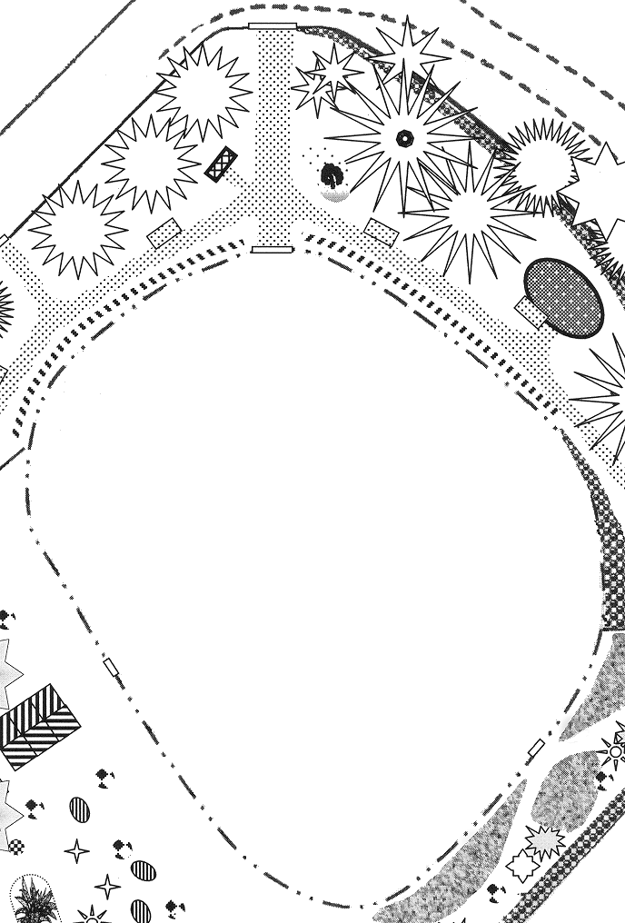
Polytunnel

Shaded lineout area

New hardstanding
Cleared growing section

Vegetable bed

Bug bank
Bulky organic matter

Cleared section under clover
SCALE
about 1:300
GROWING AREA – Quantities and costings

 | POLYTUNNELS
HOBBY 10 | NPT 10x10ft | 225.60 | 1 | 225.60
HOBBY 14 | NPT 14x24ft | 337.22 | 1 | 337.22
POTTING BENCH | 30x30x16" galv. | 18.50 | 1 | 18.50
SEED TRAY STAND | 30x30x16" galv. | 18.50 | 2 | 37.00
WATER BUTT | NHS | 4.00 | 6 | 24.00
 | Total |  |  | 642.32
 | HARD STANDING
CRUSHED LIMESTONE | <10mm per ton | 22.50 | 4 | 90.00
GEOTEXTILE | Terram 100 4.5m wide, per metre | 3.50 | 9 | 31.50
 | Total |  |  | 121.50
 | TOOLS
HAND TROWEL | Draper 21858 | 1.63 | 10 | 16.30
DRAW HOE | Draper 21853 | 4.67 | 2 | 9.34
DUTCH HOE | Draper 21852 | 4.67 | 2 | 9.34
CULTIVATOR | Bulldog 3 prong FG3144 | 17.89 | 2 | 35.78
BORDER FORK | Spear & Jackson 1684CR | 14.65 | 2 | 29.30
BORDER SPADE | Spear & Jackson 1184CR | 14.65 | 2 | 29.30
FORK | Spear & Jackson 1680CR | 14.99 | 2 | 29.98
SPADE | Spear & Jackson 1180CR | 14.99 | 2 | 29.98
RAKE | Spear & Jackson 3880CR | 11.66 | 2 | 23.32
WATERING CAN | Plysu 7L | 1.98 | 4 | 7.92
 | Total |  |  | 220.56
 | MATERIALS
PLUG TRAYS | Erin ZB60 100/case | 52.75 | 1 | 52.75
SEED TRAY HALF | Plantpak 480/case | 26.11 | 1 | 26.11
SEED TRAY FULL | NHS 100/case | 18.00 | 1 | 18.00
SEED TRAY INSERTS | Plantpack 40s 200/case | 29.31 | 1 | 29.31
LABELS | 3" 1000/box | 6.99 | 1 | 6.99
POTS 7CM | Plantpack FP7 2400/case | 50.06 | 1 | 50.06
 | Total |  |  | 183.22
 | EQUIPMENT
WHEEL BARROW | Garden builder 80L | 26.70 | 2 | 53.40
NURSERY TRUCK | Twin wheel 1.8x0.6m | 130.30 | 1 | 130.30
STRIMMER/BRUSHCUTTER | Ryobi 2-stroke 790-R | 206.95 | 1 | 206.95
HOVER MOWER | Flymo 2-stroke GT500 | 399.99 | 1 | 399.99
FLAME WEEDER | Sheen, parafin | 165.95 | 1 | 165.95
 | Total |  |  | 956.59
 | SUNDRIES
CALCIFIED SEA WEED | Chempack CSW/1 25Kg | 7.50 | 4 | 30.00
CRIMSON CLOVER | Chase, per Kg | 11.85 | 3 | 35.55
SEED COMPOST | Fertile Fibre 80L | 8.10 | 2 | 16.20
 | Total |  |  | 81.75
 | GROWING AREA TOTAL |  |  |  | 2,205.94

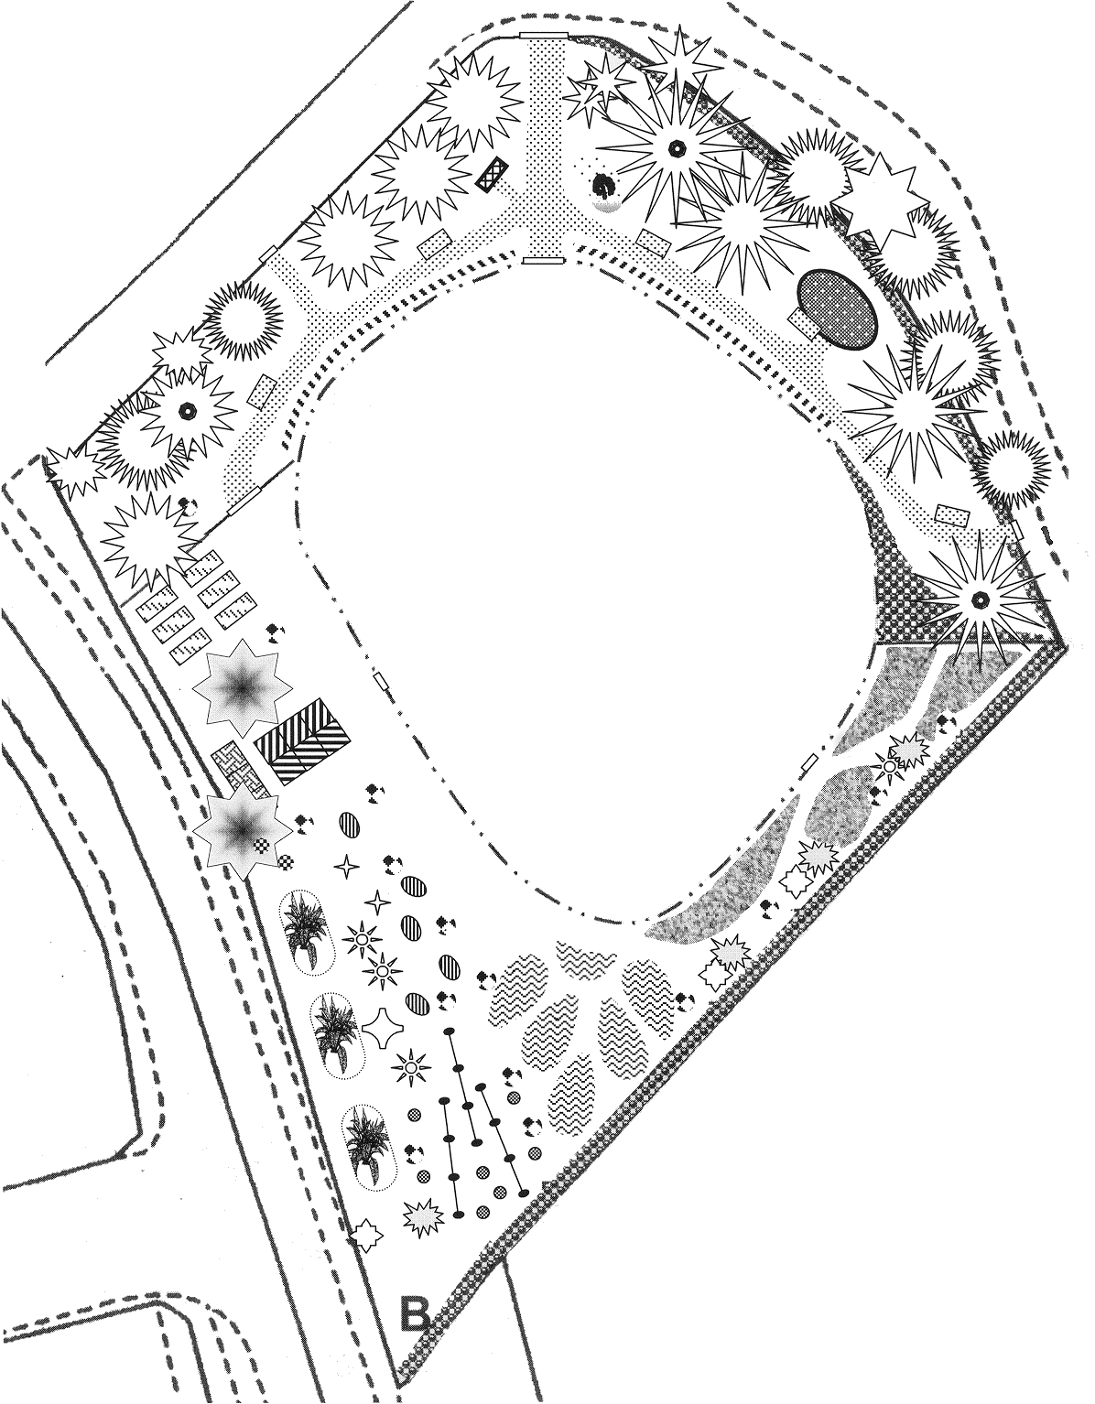
SCALE
about 1:400
OVERALL DESIGN
SANDALL GROVE PADDOCK Dec 2000

COSTINGS

Costings have not been made for preparatory work needed on the paddock before the design is developed on site. This work needs discussing as part of implementation and includes:

- Tree felling, logging and chipping
- Mechanical hedge and tree stump removal
- Determining the viability and probable removal of hydrants identified in the E and W of the paddock
- Bringing water onto the site and positioning standpipes

Costing for materials specified in the design include the following:
 | Cost (£)
Fencing, gates, hedge lines and shrub areas | 3,427.94
Public space | 1,671.68
Secondary space | 1,595.45
Growing area | 2,205.94
Total | 8,902.01

An estimate for the cost of building the design is about £12,000 and to this should be added about £1000 for machine hire.
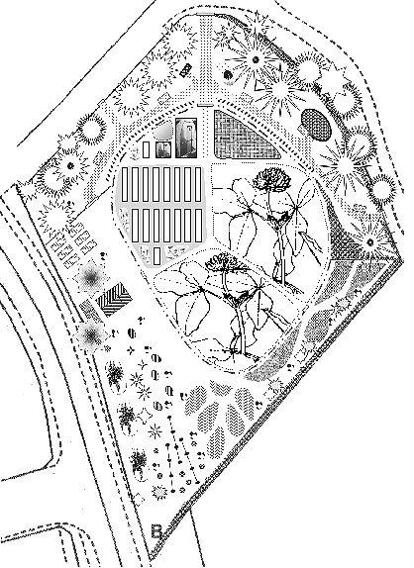

FUTURE DEVELOPMENT

The overall design has not included all the elements identified as community aspirations since it is important that the community have the opportunity to contribute to the future development of the site.

Of note amongst these are a SENSORY GARDEN, HABITATS FOR BIRDS and SPRING BULB PLANTING in the Public Space and a POND in the Secondary Space (and see also the paragraph on LANDSCAPING AND BANKED SPACE in the section on SECONDARY SPACE).

Other features that support public events on site can also be developed later on, such as a BARBEQUE PIT and CHARCOAL BURNING. The figure shows areas that are available for further development.

APPENDIX 1 – CLIENT BRIEF

Date: Thu, 18 Nov 1999 12:04:02 –0500
From: "Martin Winter" <MartinJWinter@compuserve.com>
Subject: ERDF Extension
To: marknickfisher@excite.com

Mark,

Attached is the initial rationale I had to give for the extension to our project to be agreed. It's a letter that was approved at the partnership meeting on Tuesday; and I now have to put a more developed version together for government office to approve (which they have done verbally) before Christmas.

What might help (if you're interested in playing ball) is if you could put together a position statement/strategy by which you would like to be involved, ie. the role you would like to play, suggested terms of reference, key things you think we should do, how you would support these in a mentoring type of way, the type of support you would suggest - attending
meetings, directing/assisting with work on site, telephone support etc.

Similarly, the number of days you would give to the project plus your consultancy fees and travel rates for the different "types" of support. this will help with the more detailed rationale letter I've got to send.

Can you let me know over the next 2/3 days if you are going to do this, because it will mean I don't have to busk my way through it if you do!

If you do want to be involved, could I have your thoughts sometime within the next couple of weeks? Preferably before the tree planting day on the 28th.

Speak to you soon

Martin

Our ref: ERDF Extension.ltr

16th November 1999

Carole Fox
DMBC Economic Development
PO Box 15
Nether Hall, Nether Hall Road
Doncaster,
DN1 2PN

Dear Carole

THE GLASS PARK Phase 4 - Grove Farm Community Business Centre, Business Plan
Extension to ERDF Funded Project

Following your letter dated 10th November 1999, and our discussions with Peter Robinson yesterday, I write with regard to the extension to our project.

We are making excellent progress with this project, with all landowners agreeing in principle to the development of the Community Business Centre. One of the landowners is extremely keen to start moving forward with his aspect of the project and, as a result, we have identified an area of land of approximately .5 ha (1.2 acres) for development as a demonstration market garden for the organic centre of excellence for the site. We have also identified the capacity building requirements within the local community for this and whole project to move forward.

Our extension, therefore, is to specifically allow us to commence work on this area of land as the first phase of the project:

- to prepare and develop the land as a market garden area
- to purchase tools and equipment to undertake that above, and also work on the wider site
- to employ a part-time horticultural development worker (18 months) to facilitate the above
- to develop the management capacity of the wider project through a programme of training

The funding profile for this extended work is as follows:

- £15,000 (ERDF Extension)
- £ 5,000 (private sector)
- £ 5,000 (our own fundraising)
- £ 5,000 (volunteer time)

I trust this information is, as you require, please feel free to contact me if you require any further information.

Many thanks, regards and best wishes

Martin Hilton
Chairman

APPENDIX 2 – DESIGN PROPOSAL

DESIGN PROPOSAL FOR THE

THE GLASS PARK ORGANIC DEMONSTRATION AREA

Mark Fisher and Chris Mackenzie Davey

The design process is based on a number of stages, and on the building of a relationship between the client and the design team. The client is encouraged to become an active member of the design team. In this capacity, the client will be representing not just the direct commissioners of the work, but also the community of interest that the design is intended to serve. The client will thus need to ensure its understanding of their community and set in place the ability for wider participation if necessary.

The design will be guided by the principles of sustainability, which integrate environmental with social and economic considerations. Thus the design will seek to incorporate and interconnect the roles and functions of people and their productive, trading, educational and leisure activities with the enduring use of the land. The physical development of the land and its long-term use will follow contemporary methods based on natural systems. This seeks to minimise environmental impact and requires the re-use or recycling of wastes and resources. To an extent, this will predict some of the supporting infrastructure needed in the design.

DEVELOPING THE BRIEF

As a preliminary, the client and possibly other members of the community will be invited to fill in PASE Element Generator sheets (PASE stands for Plants, Animals, Structures and Events). This is a simple exercise used to identify the clients wants and needs. The PASE sheets will be reviewed at an onsite meeting with the client as the first step in developing a brief for the design.

The onsite meeting serves two purposes. Review of the PASE sheets provides the broad context of the brief. The client interview that follows begins to add detail and set the choices that have to be made in the design. The interview is best carried out while walking the site. This helps to set the physical boundaries of the site, but also provides a picture of the general location in which the site exists.

The client should provide any maps they have of the site (scales of 1:500, 1:1000 upwards) and details of ownership or tenure of the site, and responsibility for boundaries. Knowledge of previous site use, mine workings, cabling or other potential hazards should have been identified by contacting local suppliers of gas, electricity and water, highways authorities and the residual body for British Coal information. Any structure plan designation will also need to be known, including some indication of likely developments occurring around the site, their inter-relationships and any co-dependencies.

The designers will be looking to build an informational picture of the site based on:
- Aspect, elevation and slope
- Sector analysis (sun, wind and water)
- Topography over site if complex (contour maps and field survey)
- Sense of place
- Soil
- Water
- General and specific flora, mapping major elements
- Access
- Immediate and local resources
- Contextual archaeology and history
- Current people and animal use of the site
- Availability of piped and cable services

A key element of the design is the level of access for the community. It is expected that community access will be encouraged, but decisions have to be made as to the conditions of that access. Vandalism and petty theft are an unwelcome facet of contemporary society, albeit perpetrated by the smallest of minorities. To eliminate the latter physically, leads to the erection of secure barriers, these often sending a mixed message to the community. Design can reduce some of the opportunity for vandalism within the site, and the nature of controlled access through the boundaries can set the level and the time of acceptable public presence on the site. We would ask that the client give thought to this before the onsite visit, as it will be a significant part of the interview.

THE CONCEPT REPORT

Shortly after the site visit, the design team will deliver a concept report. This will take the form of schematics that identify the major elements of the design and how they connect with each other. Interpretative text will add detail and explain any innovative or experimental concepts. Approximate locations of the elements on the site will be advanced along with the priorities that they represent and a sighting estimate of their cost. There will also be some speculation on the necessary level of future staffing and management of the site in the light of its activities and purpose.

The Concept Report is intended to be a discussion document for the client group and thus will not be exhaustive or definitive. Its contents can be presented as the start to the process of refining the design by identifying the core elements that meet the client’s priorities. It will also help to identify any consents or Planning Permissions required. Feedback from this stage will lead to an agreement of the final design elements and there will be some preliminary discussion about implementation strategies.

THE OVERALL DESIGN

The overall site design will be drawn, with indicative working plans produced of elements where they are needed for clarification. Elements will have estimates of quantities and costings for materials and there will be a chronology of the proposed phasing of development of the site. Some assumptions will be made about the implementation of the design, based on the client’s determination, and these will be used to provide a rough guide to its overall cost. It must be emphasised that the client will be contracting the implementation of the design as a separate process to the design itself.

THE WORK PROGRAM

 | Days | Cost | Expenses |  | Total Cost
Site visit, client interview and site survey | 2
Design Concept and feedback | 1.75
Design Plans and costings | 4
 |  | Overall Cost

VAT is not charged on these costs.
THE DESIGN TEAM

Chris Mackenzie Davey (OND (Hort) BA Land Arch Dip Perm Des) and Mark Fisher (BSc DPhil Dip Perm Des) are established innovators in the UK Permaculture community. Both have gained their Diplomas in Permaculture Design, which is peer recognition of their ability and experience in applying Permaculture Design.

Chris has a background in Landscape Design and was the manager at outset of Springfield Community Gardens, a three-hectare sustainable community horticulture development at the edge of a large regeneration estate in SE Bradford. As well as managing its development, Chris contributed to the day to day incremental design of that site, and has also created land-use designs for a range of clients including schools, a further education college and a housing association.

Mark Fisher has long experience of community horticulture and food growing, and has designed and built pocket parks for urban centres and fringe, and demonstration gardens for sustainable horticulture. He has been a regular teacher of natural food growing and has recently started teaching a course on Building Natural Gardens. Mark worked over the years with Chris in designing and building the food growing areas of Springfield Community Garden.

A recent collaboration has been the development of proposals for an area-wide design to increase agricultural productivity of peri-urban farmland to the SE of Bradford. The proposals were adopted by the Sustainable Farmland Management Network of Bradford District (co-ordinated by Bradford Council) and were used as the network's response to consultation for the upcoming Rural White Paper.

Chris Mackenzie Davey (cmd.leeds@btinternet)
Mark Fisher (mark.fisher@self-willed-land.org.uk)
APPENIX 3 – DESIGN QUESTIONAIRE

DESIGN QUESTIONS – 20th September 2000

SANDAL GROVE PADDOCK
My aim is to involve all those interested in as much of the design work as possible. Now you have had some time to think about it, I would like to ask you some questions about the outline design. Your answers will help with the creation of the more detailed design, and then it will be possible to cost out the development of the paddock. The five question areas are introduced with some background explanation. Please give as much information as you can in your answers, either on this letter or on a separate sheet. Feel free to comment on other areas of the outline design if you wish, and send all your comments to me at the address given above.

Thankyou.

1. PRIMARY AND SECONDARY SPACES
Community gardens and demonstration areas are more highly developed than most public space, and usually have access restricted to periods when there is supervision. This could have been the approach with Sandall Grove Paddock, but the capacity to provide site supervision is uncertain at present, and a site that is not open very often will detract from a community or public role. Thus the idea has evolved of having a primary space that is publicly accessible without supervision, and a secondary space where access is restricted to when supervision is available. This separation of spaces also fits with the purpose of the funding from SRB5, which is that part of Sandall Grove Paddock be a working demonstration of organic food production. Thus the secondary space can be a market garden.

A market garden style fits with the scale of the site and the local needs of the community. Experience from city farms and community food growing projects has shown that food production needs greater protection than is given to public spaces for it to be a success. Fouling by pet animals is one problem, as is the potential for rabbit damage during autumn and winter. But it is the magnetic attraction for some to randomly pull up plants that is the greatest problem. Vandalism or theft has greater consequences for food production than it does for flowers in a public area – the food plants have to be productive and with a realistic yield.

Do you agree with the idea of primary and secondary spaces?

2. TREES
There are many mature trees in Sandall Grove Paddock, which suggest an original purpose as a wooded pasture. While I suspect this wood pasture was ornamental in function, the historic role of wood pasture has been for the grass to provide grazing for livestock (which would have been deer in private parkland) with the trees providing timber, underwood (poles from coppicing and pollarding) and pannage (acorns for pigs). The tree part of wood pasture was always managed to maintain productivity and it is the intention to adopt this historical wood pasture management for the trees on Sandall Grove Paddock. Leaving aside a proportion of feature trees in the primary space, the remainder will be coppiced and pollarded. The benefits from this will be logs that can be used in garden building (particularly in the primary space) an improvement in the amount of sun cast on the secondary space; a reduction in water use from tree roots and, eventually, product in the form of poles. It is likely that a few trees will be removed, mainly those at the southern-most tip.

Do you agree with the proposed management of the trees on the site?

3. POND
A stretch of permanent water soon becomes a haven for aquatic life. The frogs and toads and many of the insects attracted by water play a significant role in pest predation and natural balance. Thus a pond is a key part of the landscape for organic growing. Ponds always raise safety fears, which are intensified by the question of liability. They can be made safer by surrounding with fencing or some other barrier (i.e. upright logs) by netting the whole pond, or by designs which reduce the surface area of the water (i.e. a honeycomb of stones). All of these methods in some way reduce the effectiveness of the pond as a wildlife habitat.

Do you want a permanent water feature, and where would you put it?

4. FENCING AND ACCESS POINTS
The purpose of the fencing and the position of the various access points are designed to channel people through the site in ways that fit with the function of the site. Thus there are no gates and access is discouraged along the SE and SW fence lines. These are boundaries for the market garden of the secondary space. The fence there doesn’t necessarily have to be imposing, just obvious that it is not meant to be passed. A hedgerow planted inside will reinforce the notion of impassability. On the other hand, the fence lines on the NW and NE will have lockable gates for general access, and they will have stepovers and kissing gates (potentially wheelchair accessible) dotted along to discourage the climbing over of the fence. This can be reinforced by hedge planting that has obvious gaps where there are these access points. It is not the intention to block any view of the site by the fencing and hedging. The internal fence is primarily there as a deterrent to rabbits but its northern section also creates (along with the proposed landscaping) the restricted access to the market garden area.

Do you agree with the proposed fencing and access points?

5. COMPOSTING TOILETS
The provision of toilet facilities was probably not sufficiently covered in the outline design. The expense of bringing main sewers on site is probably too high, as would be the cost of a septic tank. Therefore a conventional public lavatory block is probably not an option (it may be available anyway in later development of Grove Farm). Composting toilets remove the need for main sewers or a septic tank because they do not use water flushing and the wastes are processed on site. (There is no technical reason to prevent it, but it is probably best to use this compost on non-food-growing areas.) At a minimum, a composting toilet could be provided for workers in the secondary area, and with access opened up from the public area when community events take place. Composting toilets can be home-made using very low technology (some excavation and building a screened platform, and using a wheelie bin for the container) or higher technology systems can be bought in that usually require an electrical supply.

Should there be composting toilets?

Would you be interested in seeing the various stages of the design, as they are produced? (Please provide your name and address)

